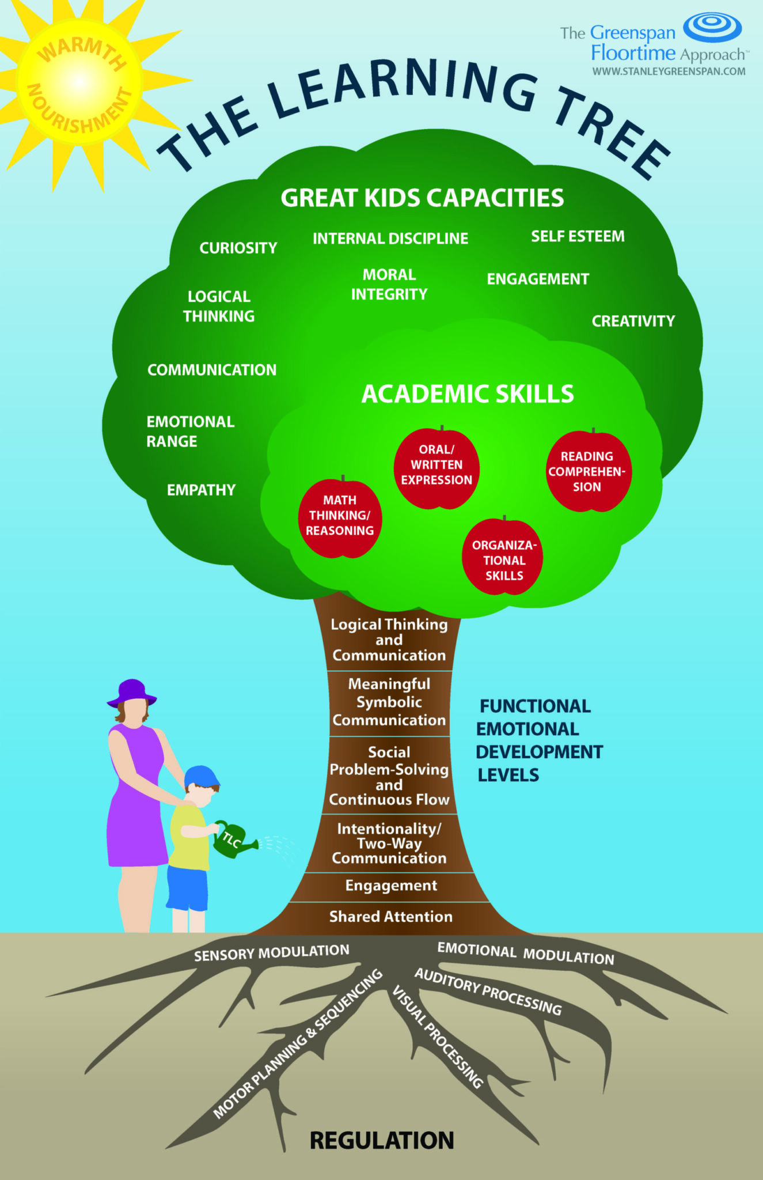
PP

DIR
- Developmental: Addressing the underlying, internal systems as foundations to learning.
- Individual differences: Sensory profile, unique learning style, personality, interests.
- Relationships-based: Through the context of warm, responsive, and trusting relationships, we are able to create challenges that help children move "up" through the foundations, trunk of the learning tree, and bridge skills into more complex developmental capacities.

The Learning Tree
- Roots: Sensory regulation, emotional regulation, ideas, motor planning
- Trunk foundational capacities 1-3: when Regulated (#1), our body/brain has the capacity for shared attention. With shared attention, we can have Engagement (#2), which paves the way for back-and-forth circles of Communication (#3).
- Trunk capacity 4: Foundations 1-3 pave the way for Shared Social Problem Solving (#4), where children engage in back-and-forth interactions to problem-solve in real life and pretend-play together.
- Trunk/tree capacities 5+: In pretend play, children develop symbolic thinking to act out emotions, perspective take, and build bridges between play and "real life" logic that is needed for more complex social and academic experiences.
- Note - Natural ebbs and flows. For example, we may be supporting regulation for 10 minutes before getting to a place of communication and problem-solving in pretend play, and then go back to regulating our emotions and sensory system. This is normal, and why in DIR therapy, we are moment-to-moment wondering where along this tree trunk a child is so that we can respond and challenge/not challenge them accordingly.

